KUMI –FRIMPONG DEREK
SM/SMS/09/0029
6TH OCTOBER,2009

TITLE: An experiment to determine the modulus of Elasticity
Aim: To determine the modulus of elasticity of given metal bar
Apparatus: Dial gauge, knife-edge with stirrup, weight holder, measuring tape, spring balance, retort stand.
DAIGRAM

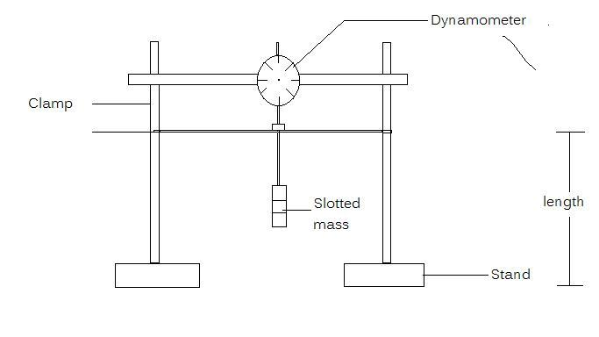

Theory
Tensile stress is the force per unit area
Tensile stress= $\frac{force(F)}{Area(A)}$
If the extension of the bar is e and its original length l_{o} ,then tensile strain =$\frac{e}{l}$
F α e and A α e
$\frac{\begin{aligned} \\ f\end{aligned}}{a}$α $\frac{e}{l}$ since A and l_{o} are constant
From hooks law which states that provided the elastic limit is not exceeded then stress(F/A) is directly proportional to strain e.i stress α strain
Stress=E×Strain (where E is the youngs modulus of elasticity)
E= Stress/Strain
E=(f/A)/(e/l)
E=(FL)/(A_{e})

PROCEDURE
The dial guage was mounted on the knife edge with stirrup. The flat bars was positioned accurately on the two supporting knife edges having the possibility to move in X and Y direction. The 8u8geometric data of the set up and the bars was recorded several times at different positions. The height , with and length of the metal bar was recorded using a rule. The metal bar was loaded with 250g of mass and it was well centred between the knife edges. The dynamometer and plunger of the dial guage were also mounted and the dial guage show full deflection. The mass was carefully reduced by 50g intervals and recorded , the extension e in each case is recorded.

OBSERVATION
LEAST COUNT
Dynamometer 0.01mm
Rule 0.1cm

Height(b)=28.5cm
Width of the bar= 1.5cm
Lenght of the bar =45cm
Mass/g | F/N | e₁/cm | e₂/cm | e₃/cm | e₄/cm | e₅/cm | ((e₁+e₂+e₃+e₄+e₅)/5)/cm
250 | 2.45 | 32.5 | 32.6 | 32.3 | 32.9 | 32.4 | 32.5
200 | 1.96 | 26.0 | 26.1 | 25.8 | 26.3 | 26.0 | 26.0
150 | 1.47 | 19.5 | 19.6 | 19.4 | 19.7 | 19.4 | 19.5
100 | 0.98 | 13.0 | 13.0 | 12.9 | 13.2 | 13.0 | 13.0
50 | 0.49 | 6.50 | 6.50 | 6.50 | 6.6 | 6.5 | 6.52

CALCULATIONS
SLOPE=13.25cm²
E=FL/Ae
E=(2.45*0.285)/(6.75*10⁻³*0.325)
E=318.29Nm⁻²

DISCUSSION OF RESULTS
As the mass was being decreased, the extension was also decreasing. That is obeying hooke’s law which states that the force applied to an elastic material (metal bar) is directly proportional to the extension provided the elastic limit is not exceeded.
ERRORS
1. There might not have been a full deflection of the dial guage.
2. The load on the metal bar might not have been well centered.
PRECAUTION
- The load on the metal bar must be well centered
- The dial guage must be fully deflected.

CONCLUSION
The Young’s modulus of elasticity is, E=318.29Nm⁻².

